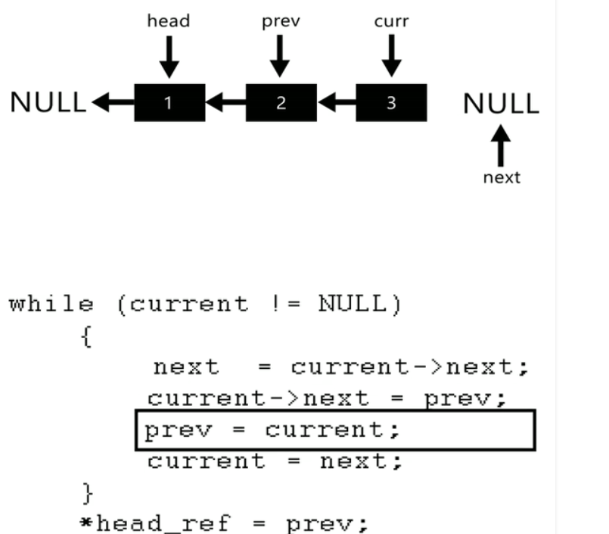

THE BASIC IDEA IS TO USE 3 POINTERS , PREV, CURR AND NEXT .

->>> JUST KEEP ON ITERATING AND SWAPPING THE LINKS

->>IN THE END POINT THE HEAD TO THE PREV(AS IT WILL BE THE LAST NODE